**GAUTHAM K**

* create table DRIVER(DCODE int primary key,DNAME nvarchar(20) not null,DOB date, GENDER nvarchar(10));

create table CITY(CCODE int ,CNAME nvarchar(20));

create table TRAVEL(Tripid int primary key,DCODE int foreign key references DRIVER,DATE date,FROM_CITY nvarchar(20),TO_CITY nvarchar(20))

select*from driver;

select*from city;

select*from travel;

update travel set to_city='coimbatore' where tripid=3;

select*from driver where GENDER='female';

1. select*from driver;

1. select*from city;

1. select*from travel;

1. select*from driver where GENDER='female';

1. select*from TRAVEL where FROM_CITY = 'Madurai' and TO_CITY ='Chennai';

1. select t.tripid trip_id_of_kenry

from travel t left join driver d on t.dcode = d.dcode

where d.dname = 'Kenry';

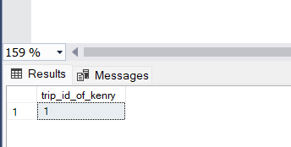

1. select * from travel

where date = '2023/03/20'

1. select * from udf_no_of_trips_();

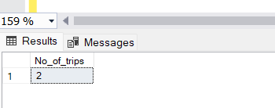

select * from triggertables;

create or alter trigger dbo.travelupdate

on dbo.travel

after update

as

INSERT INTO dbo.triggertables(UpdatedDate,Operation)select getdate(),'UPDATE' from deleted;

go

update travel set FROM_CITY='Cbe' where Tripid=5;

go

create or alter trigger dbo.traveldelete

on dbo.travel

instead of delete

AS

INSERT INTO dbo.triggertables(UpdatedDate, Operation)select getdate(), 'DELETE' from deleted;

delete from travel where FROM_CITY='chennai';

1. select * from travel;

